



System Requirement Specification (SRS)

FOR

**SAJIDA Telehealth Application**

## Categories:

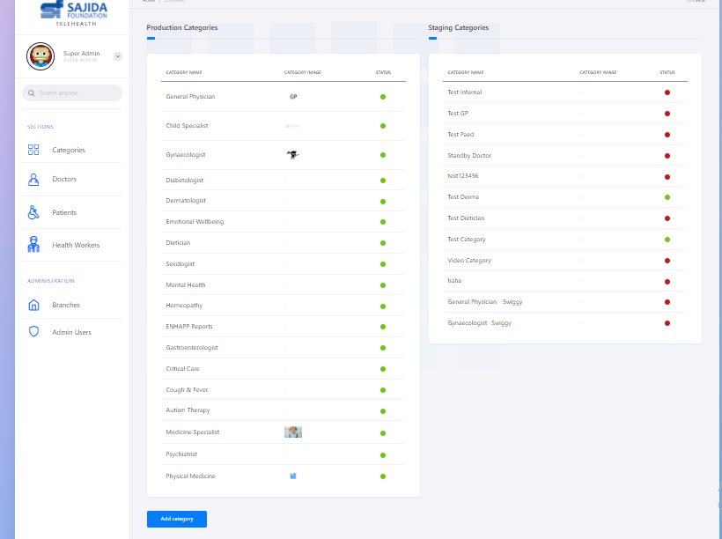

In the module ‘categories’ -Admin can see different categories of Doctors are available and also admin can add new category of doctors in the ‘Add category’.

## Doctors:

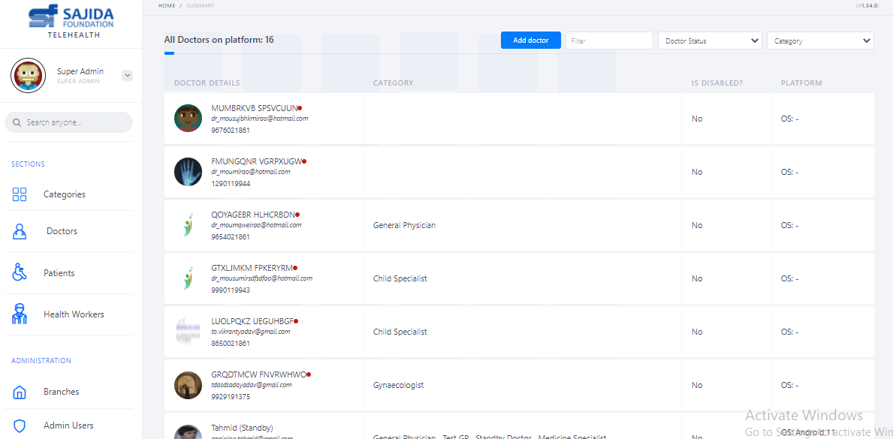

In the Module ‘Doctors’-Admin can see All the doctors available of all categories and also can Add new doctor in ‘Add Doctor’ as the following figure-

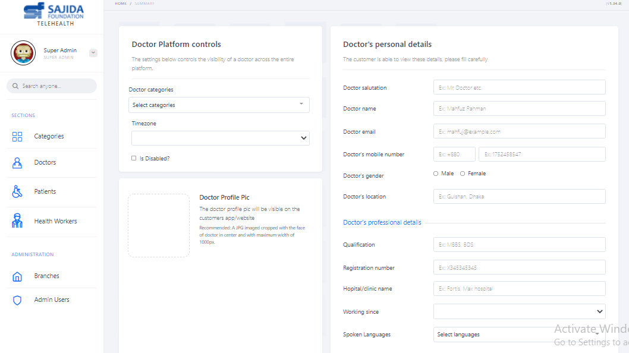

**Fig**: Add new doctor in the module ‘Doctors’

## Patients:

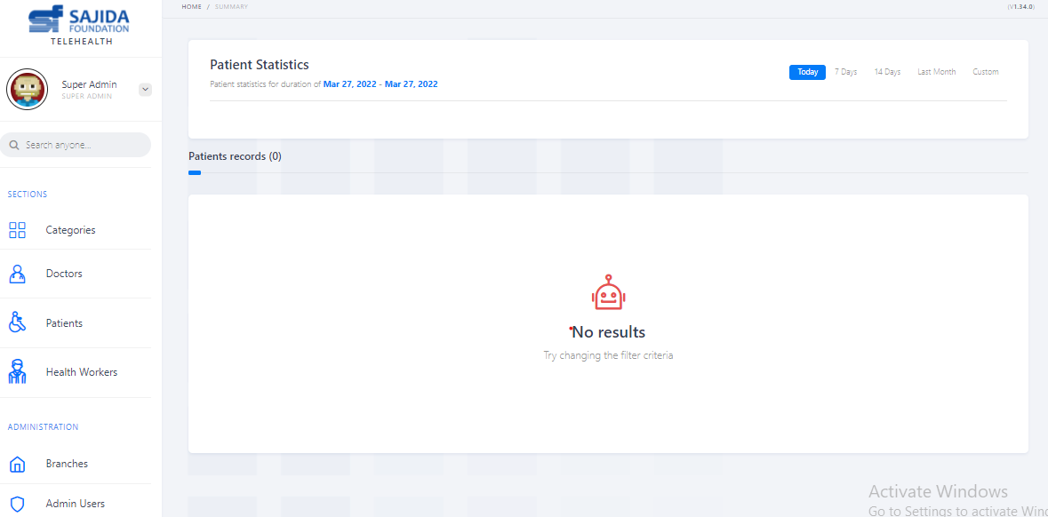

In the module’ Patients’- Admin can see patients Records for todays, for last 7 days or Last months and even you can customize date.

## Health Workers:

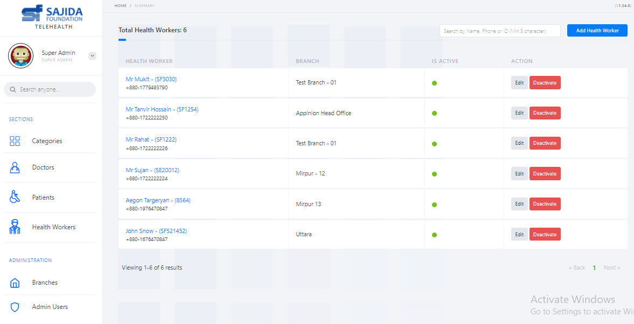

In the Module ‘Health workers’-Admin can see All the Health workers of all branches available and also can add new Health Worker in ‘Add Health Worker’

## Branches:

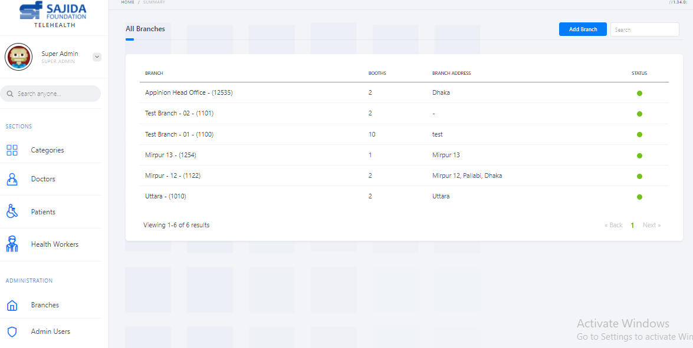

In the module ‘Branches’-Admin can see all the branches with their booths along with the branch addresses.

Also,Admin can add new branch in the ‘Add Branch’

## Admin users:

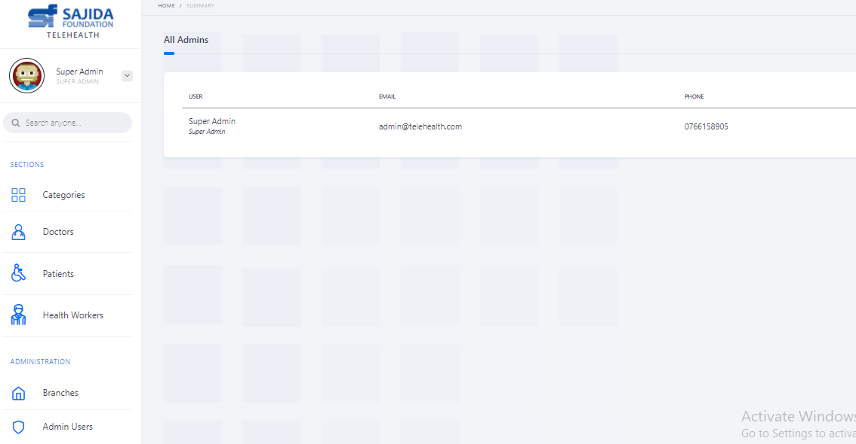

In the module ’Admin Users’- can see all the user with email and phone number.

## 2.Sajida Telehealth- Doctor Application:

**There are following 2 Modules:**

**1. Completed Consults- located in left column.**

**2. Callback Requests- located in right column.**

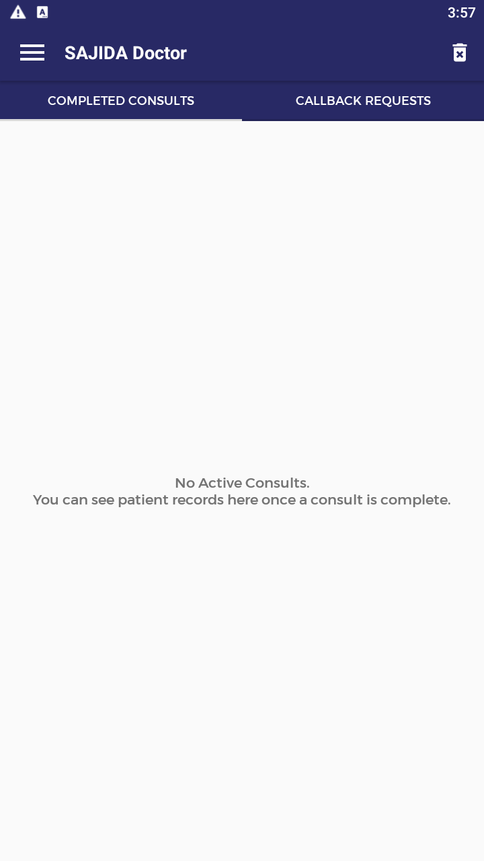

**1.Completed Consults-**

It shows that,which appoinments were done with assigned patients.

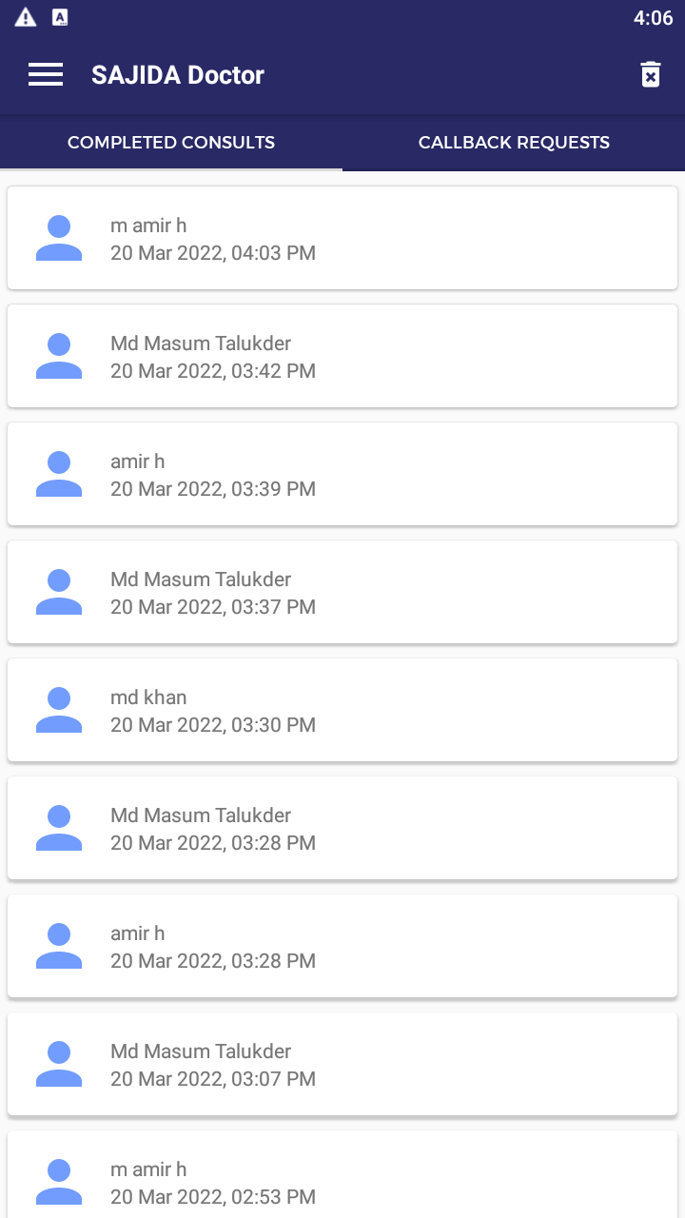

**Fig: Completed Consults**

**2. Callback Requests-**

When patient is added by the Health Worker for a doctor gets a callback Requests for that particular patient. Here, Doctor in advance gets to know about upcoming consultation will have to attend where patient and time is clearly mentioned.

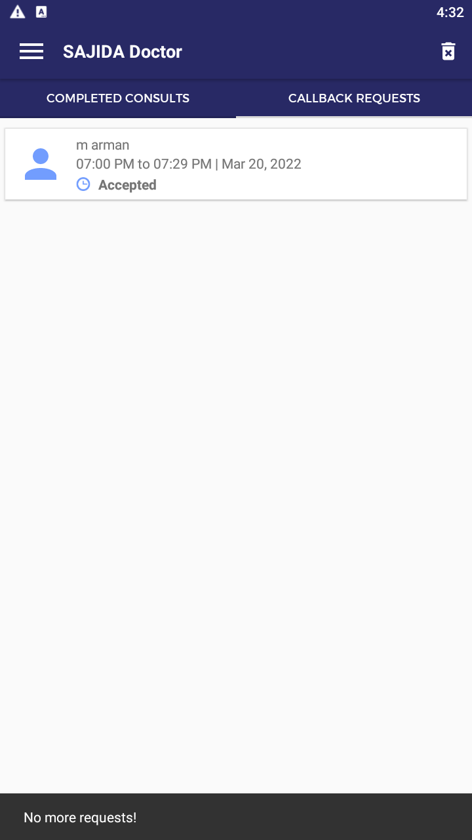

**Fig: Callback Requests.**

### 3. Sajida Telehealth- Health Worker Application:

There are following 3 Modules:

1. Appointments

2. Patients

3. Settings

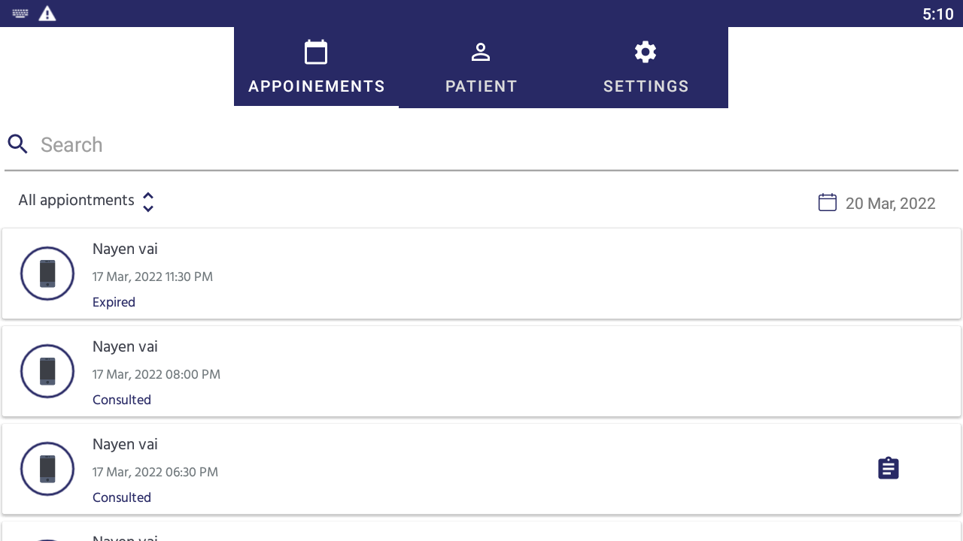

**Fig: 3 module**

**1. Appointments-**

Here we have a filter sorted by – Upcoming, Completed, and Expired.

Upcoming- It shows future Appointments

Completed- It shows Appointments which are done by the Doctor

Expired-It shows those Appointments are not conducted by the Doctor or Patients

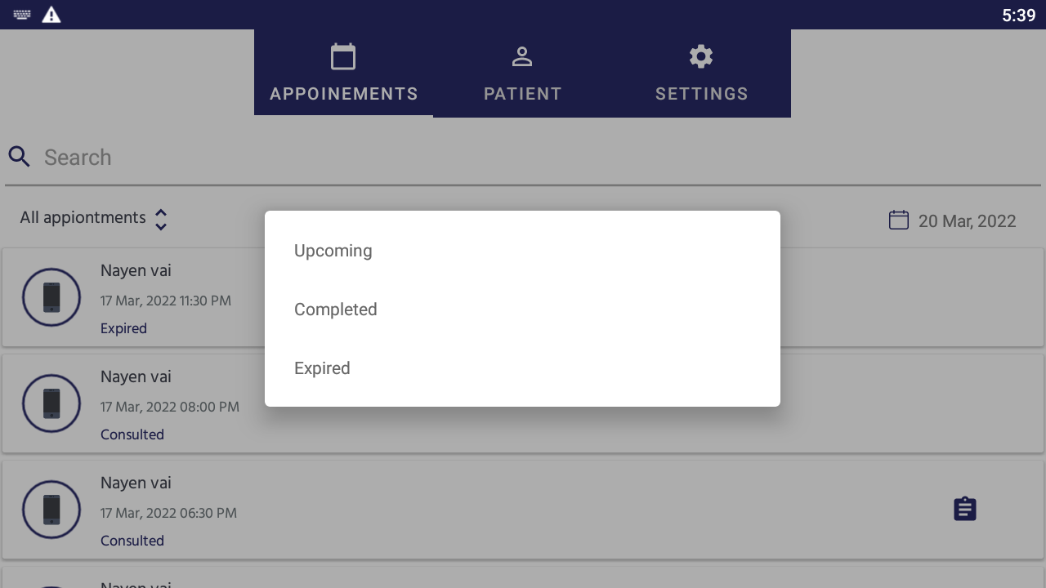

**Fig: Appointments**

#### Patients-

Here Health Worker add new patients, where they add patients by their Phone number

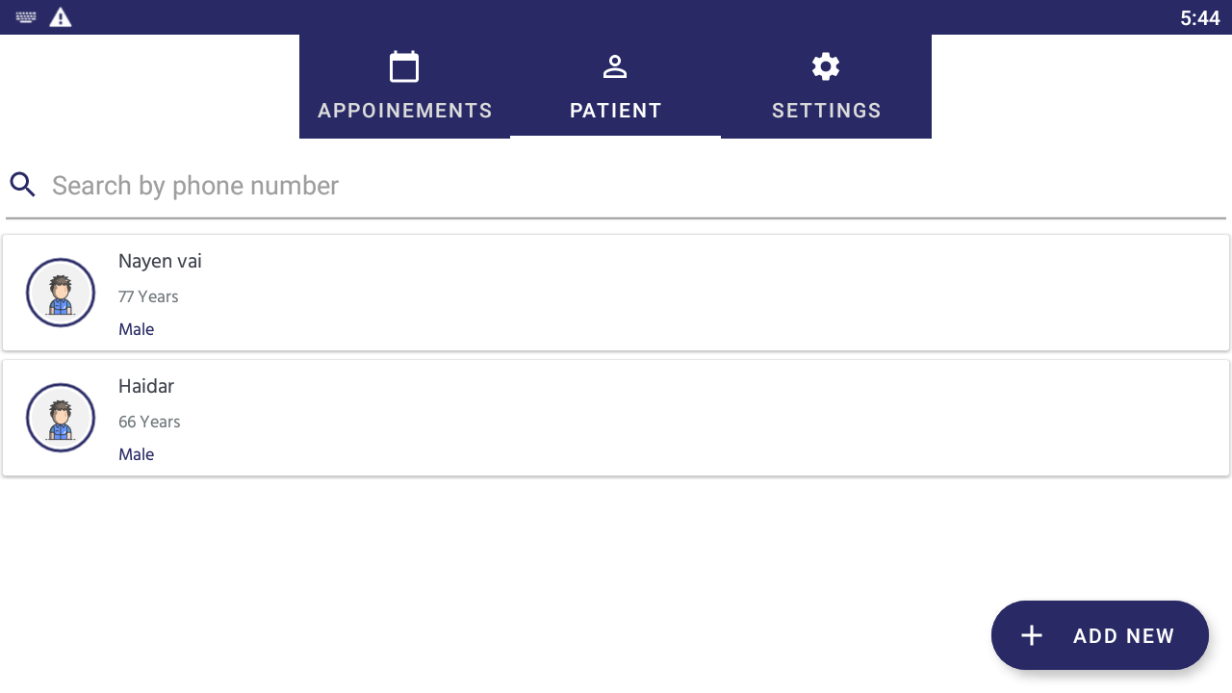 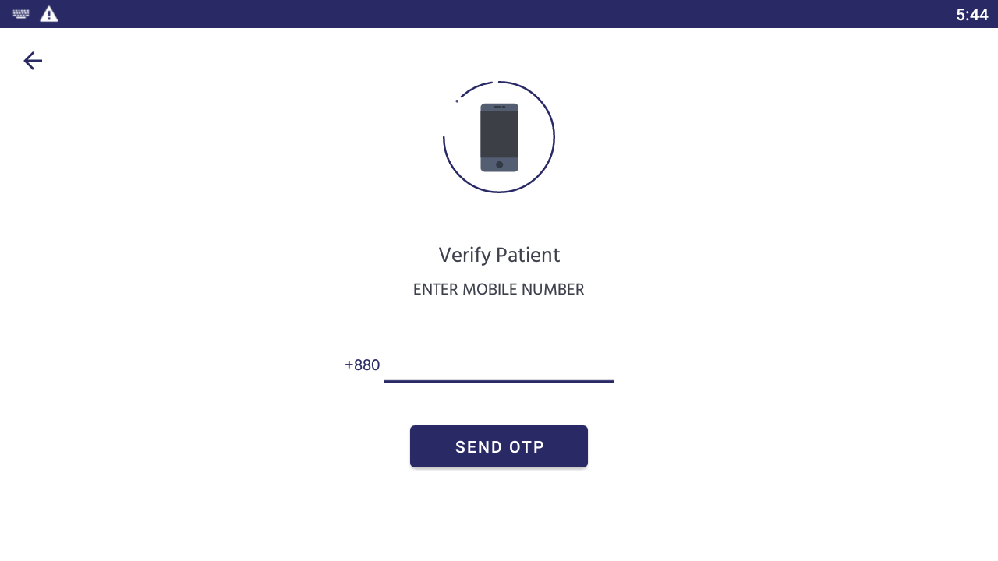

**Fig: Patients**

**3. Setting- Logout option**

##### Sajida Telehealth- Patient Application:

There are following 4 Modules:

**1. APPOINMENT**

**2. VITALS**

**3. PRESCRIPTION**

**4. REPORT**

**1. Appointment**-

1. All appointment: patient can see all upcoming or completed appointment with their doctor
2. Upcoming: patient can see all upcoming appointment with their doctor
3. Completed: patient can see all completed appointments with prescription attached.

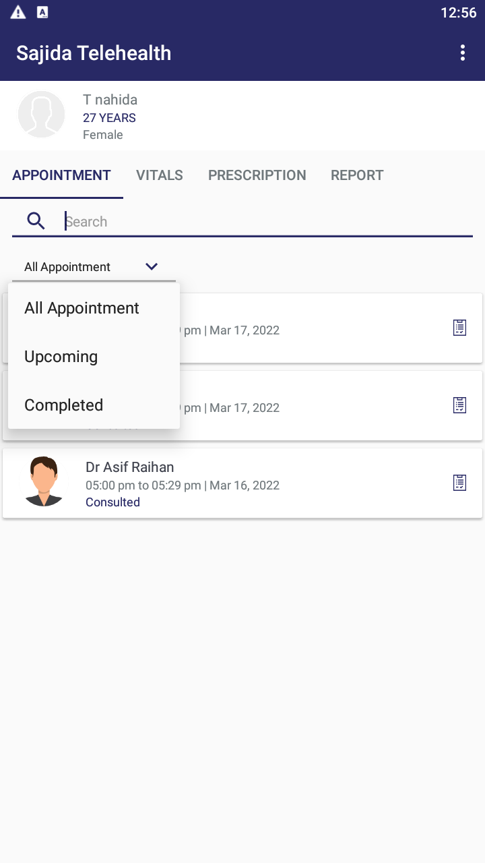

Fig: 1.Appoinment.

**2. Vitals**-

In this feature, patients will submit their vitals for instance, BP, Body temperature, pulse rate, Body weight, Blood Sugar etc.

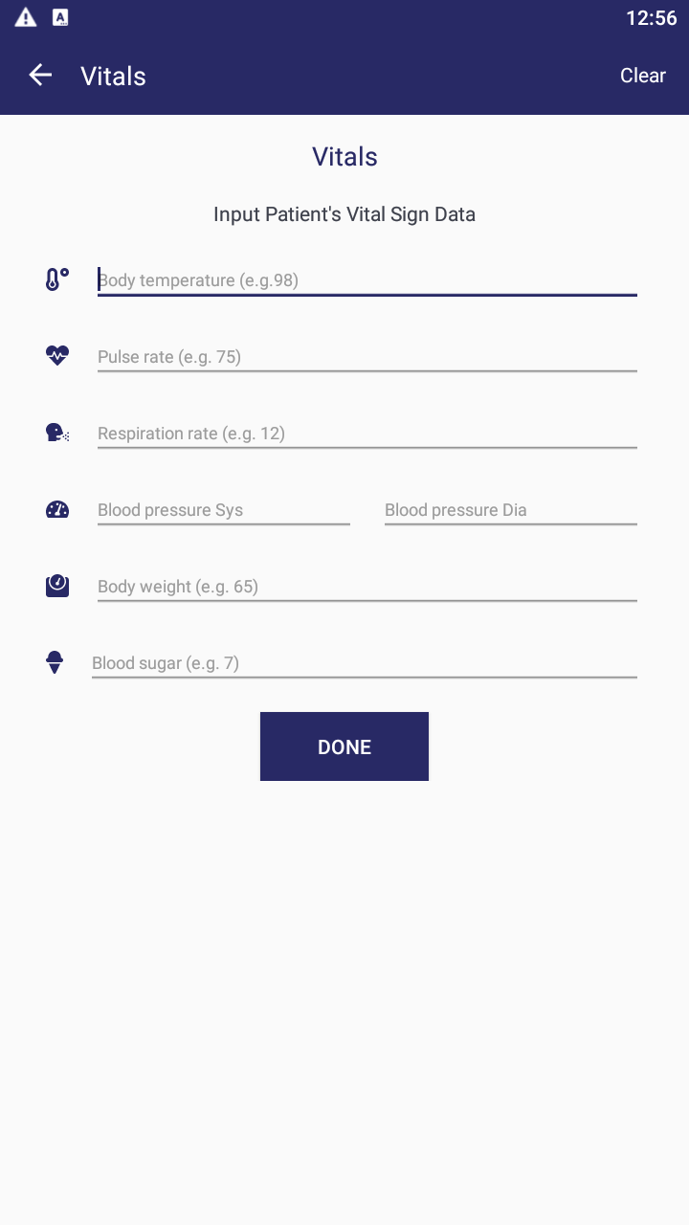

Fig: 2.Vitals

**3. prescription**-

In this feature, patients can see their prescription.

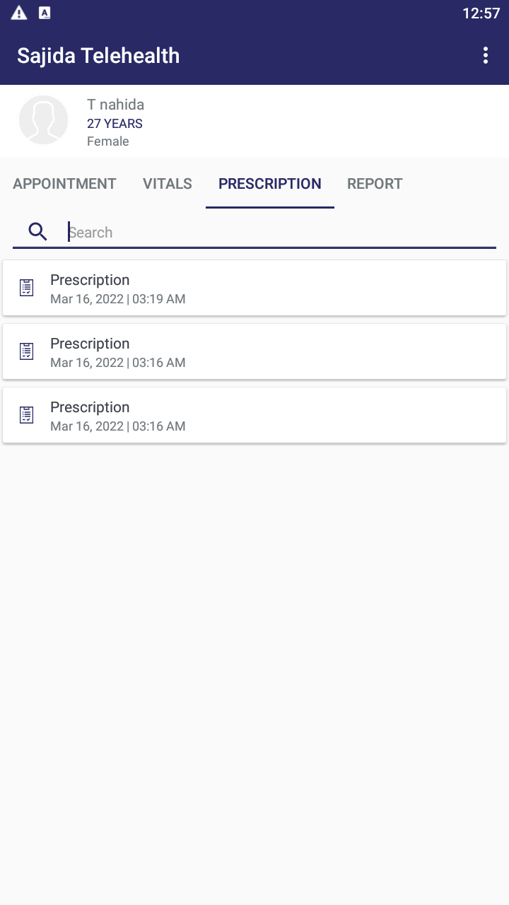

Fig: 3.Prescription

**4.Report**-

In this feature, Patients can submit their report if they have any.

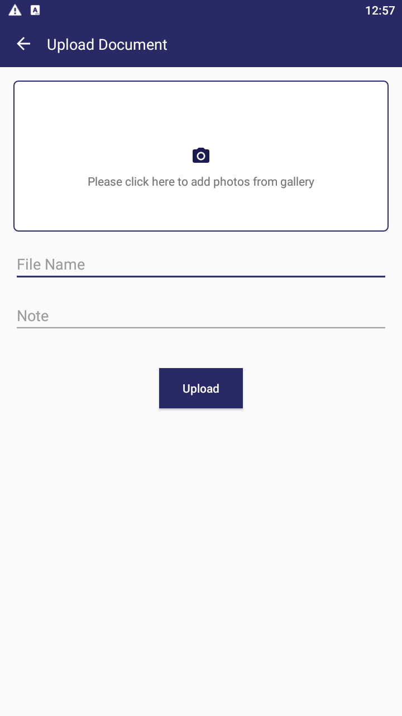

Fig: 4.Report